SURAT REKOMENDASI MENGIKUTI PROGRAM BEASISWA UNGGULAN
KEMENTERIAN PENDIDIKAN DAN KEBUDAYAAN

Yang bertanda tangan di bawah ini:

Nama : Dr, I Nyoman Sukma Arida, M.Si.

Jabatan : Wakul Dekan III Fak Pariwisata Unud

Instansi : Unud

Alamat : Jl. Goris No 7 Denpasar

Telp. : (0361)235970

Email : fpar.unud@gmail.com

Memberikan rekomendasi kepada:

Nama : ................................................................................................................

Jabatan : ................................................................................................................

Instansi : ................................................................................................................

Alamat : ................................................................................................................

Penilaian terhadap calon peserta (isi dengan tanda X):
 | Kurang | Cukup | Baik | Sangat  Baik
Kepemimpinan |  |  | *
Partisipasi dalam komunitas
Potensi untuk maju
Integritas
Kemampuan berbahasa Inggris
Sehat jasmani dan rohani

Alasan memberikan rekomendasi:
Ketentuan pengisian:
- Seberapa dekat dengan pelamar;
- Prestasi yang telah dicapai pelamar beserta aktivitasnya;
- Alasan memberikan rekomendasi;
- Boleh menambah lembaran.

Pelamar memiliki prestasi berupa......selama kuliah di fakultas.
..........................................................................................................................................

.Pelamar memiliki integritas dan ketekunan dalam menempuh studi. Pelamar memiliki motivasi yang kuat dalam belajar. .........................................................................................................................................

..........................................................................................................................................

..........................................................................................................................................

..........................................................................................................................................

..........................................................................................................................................

..........................................................................................................................................

..........................................................................................................................................

..........................................................................................................................................

..........................................................................................................................................

..........................................................................................................................................

..........................................................................................................................................

..........................................................................................................................................

..........................................................................................................................................

Demikian surat rekomendasi ini dibuat dengan sesungguhnya dan tanpa ada paksaan dari pihak manapun serta akan dilaksanakan dengan sebagaimana mestinya.

Denpasar, 3 Oktober 2020

Pembuat Rekomendasi

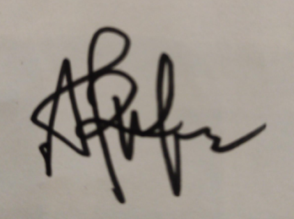

(Dr. Nyoman Sukma Arida, M.Si.)

